[C++ hardware reset (not ROS) · Issue #2161 · IntelRealSense/librealsense (github.com)](https://github.com/IntelRealSense/librealsense/issues/2161#issuecomment-408779150)

[“Frame didn't arrive within 15000” during long run with D435 or D435i · Issue #7252 · IntelRealSense/librealsense (github.com)](https://github.com/IntelRealSense/librealsense/issues/7252)

重启程序后被更改为USB2.0

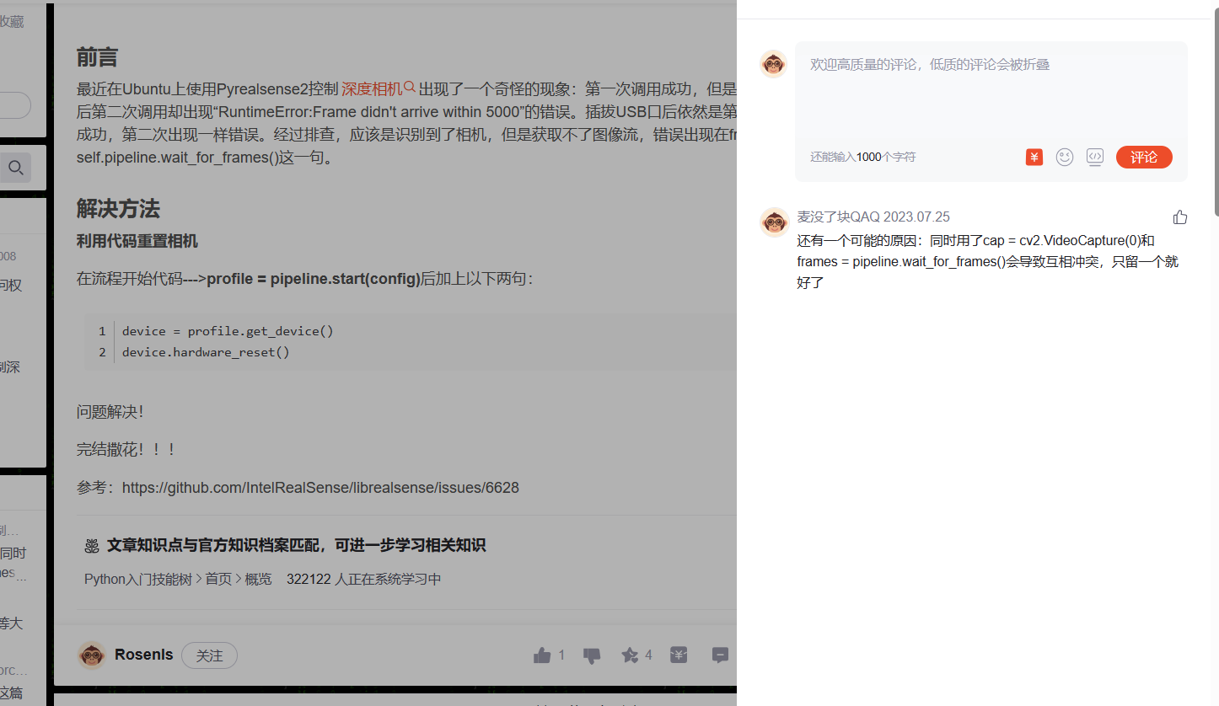

[Tracking camera T265 – Intel RealSense Depth and Tracking Cameras](https://www.intelrealsense.com/tracking-camera-t265/)

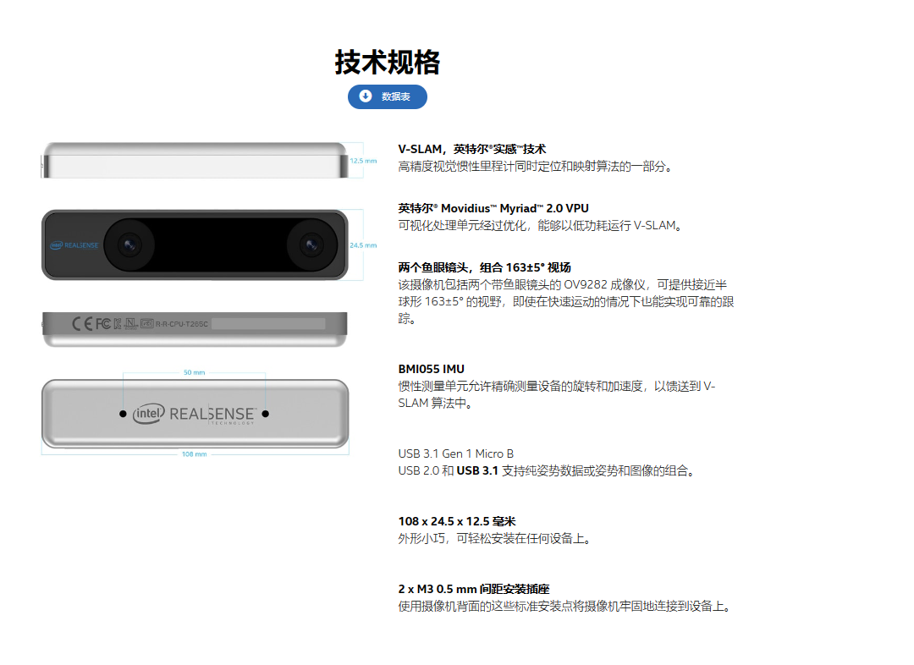

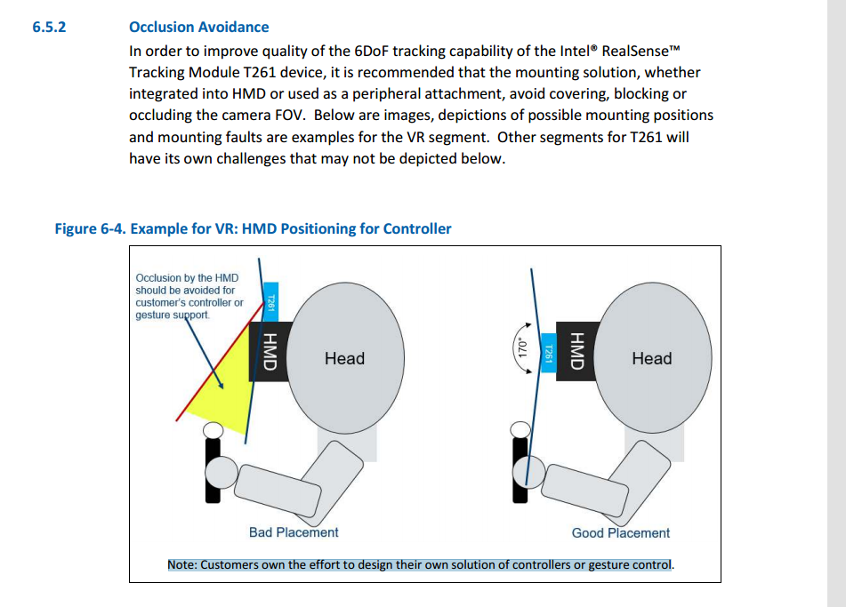

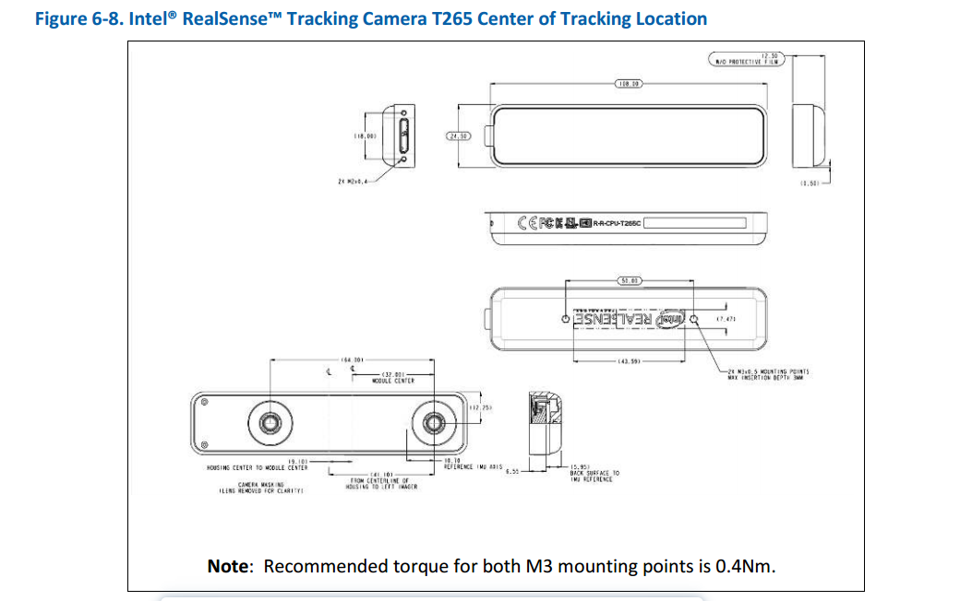

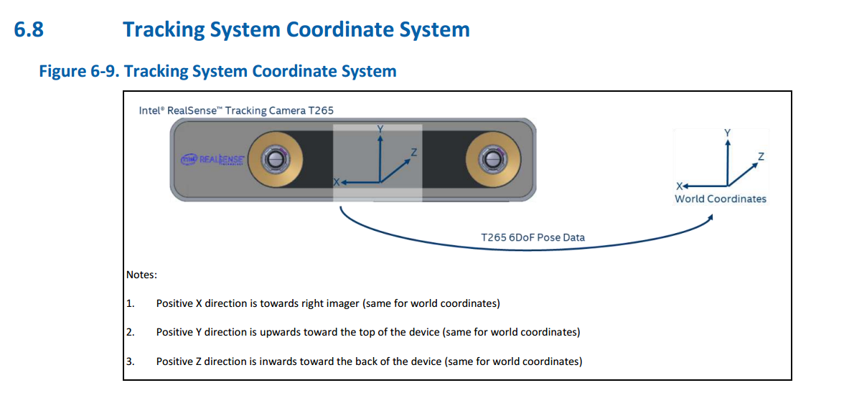

位姿相关

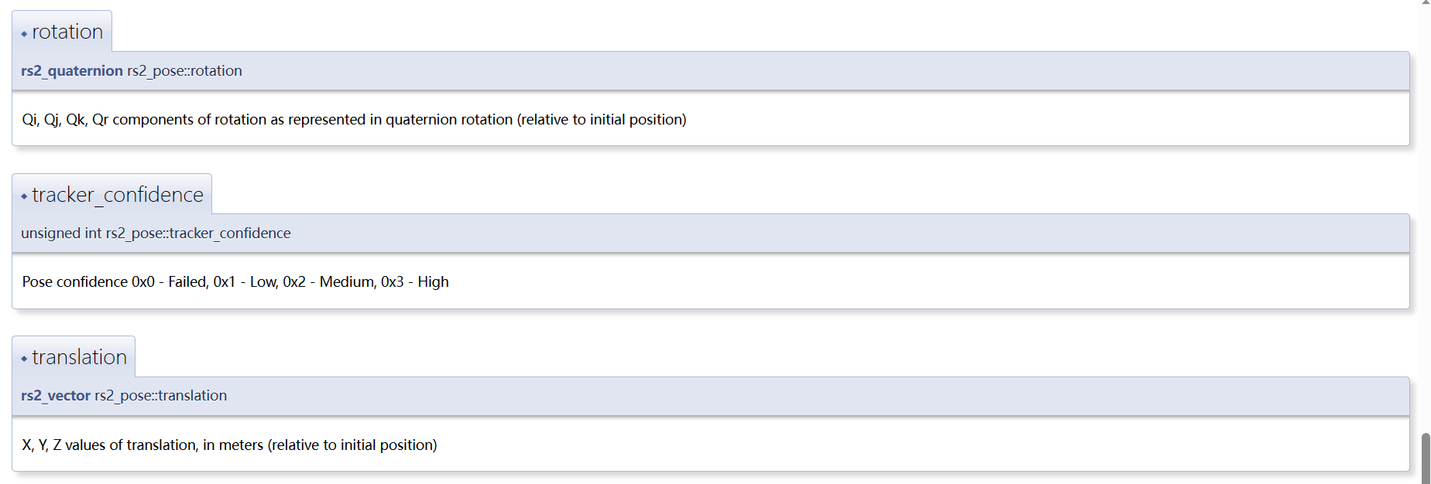

[Intel® RealSense™ Cross Platform API: rs2_pose Struct Reference (intelrealsense.github.io)](https://intelrealsense.github.io/librealsense/doxygen/structrs2__pose.html#af985dd52f65f7a933dce55844b7ca29e)